# 

# 

# 

# 

# 

# 

# 

# 

RISK AND PROCUREMENT MANAGEMENT

Table of Contents

1. Introduction 3

2. Development of Bespoke Risk Management Plan and Justification of KPIs 3

3. Identification of Risks, Development of Risk Criteria, and Mitigation 5

4. Explanation of the Process of the Utilization of Simulation of Monte-Carlo and Utilization of its Results 8

5. Reflection 8

6. Conclusion 9

Bibliography 10

Appendix 11

# 1. Introduction

Planning along with construction has been done by ***“London Heathrow Airport”*** for approximately two decades. The greatly congested Airport was ultimately forthcoming with the anticipation of **Terminal 5(T5)** (Wang *et al.* 2022). T5 has been the latest home in the case of ***“British Airways International (BA).*** Presently, this occupies the greatest amount of the space at the Heathrow in comparison to different airlines (sfuheathrowcase.wordpress, 2023). Hope has been present within both ***British Airport Authorities (BAA)*** and BA in the case of the windfall possessed by the revenue by cause of the expansion. A lot of issues along with risks are present within ***“Heathrow Airport Terminal 5”*** and for this, Bespoke Risk Management will be required. By the identification of risks within the case study of ***“Heathrow Airport Terminal 5”, a*** risk register is necessitated to be developed. The process of the utilization of the simulation of Monte Carlo and its results will be discussed. The learning of this report will be personally reflected in this context.

# 2. Development of Bespoke Risk Management Plan and Justification of KPIs

As this is a huge construction project, there is a tendency to slip timelines and there is a beginning of the movement of entire completion dates. Due to these delays, there is a delay in making decisions that affect the entire quality in several areas (Shayan *et al.* 2022). This includes the decrease in testing, as well as, the orientation of staff with the assertion. Due to the presence of issues in the project, there is a requirement for a Bespoke Risk Management Plan.

| **RISK** | **TRIGGER** | **OWNER** | **RESPONSE** | **REQUIREMENT OF RESOURCE** |
| --- | --- | --- | --- | --- |
| –Issue in Entire quality of marked decrease in testing and | -Topic of the postponement | -Project Manager | Responsibility should be taken by Project Manager | -Resources for backup  -Appropriate schedule plan |
| -Risk of the expectation of an increase in revenue | -Delay of making decisions | -Senior Accounts Manager | Responsibility should be taken by Accounts manager | -Conducting meeting of the employees weekly  -Involvement of entire employees in making strategic decisions. |
| -A loss of options of recovery of cost, failed contracts along with huge adverse political implications | - Irresponsible and inefficient members included in the team for doing the project | -Project Manager  -Team Leader  -HR Manager | Project Manager along with the Team leader should be responsible for the management of tasks required for the progress of the project. | -Training should be provided to the employees selected for the completion of the project  -Effcient candidates should be hired possessing sufficient capabilities for the completion of the project. |
| - |  |  |  |  |

**Table 1: Bespoke Risk Management Plan**

(Source: Self-Developed)

It has been analyzed from the above plan of management of risks that there has been a requirement for the management of risks for the further improvement of the project. In addition to that, this plan is required to mitigate the risks further to reduce the challenges faced by London Heathrow. In the case scenario of London Heathrow, there has been the presence of seven **Key Performance Indicators (KPIs).** As per the case scenario, the Engagement of BAA along with BA has been present in the improvement of project T5. In addition to that,  *the* entire facets of aviation have been overseen by ***Civil Aviation Authorities (CAA).*** Influence of different aspects including delays along with financial risks is present in the case of the completion of the project successfully (Gözaçan and Lafci, 2020). Quality is improved by BAA along with BA as it has been known as one of the biggest companies in transportation. Moreover, the greatest medium of revenue in the case of the airport refers to landing fees on the basis of pricing per seat. Passengers are facilitated by traversing Heathrow as possible.

# 3. Identification of Risks, Development of Risk Criteria, and Mitigation

The risks in the case of Heathrow Terminal 5 are the risk of technical failures and interruption in business. There are the major risks that have been identified in the case scenario and the minor risks that have been detected from the case study are the loss of confidence along with the customers. Apart from this, there has been a presence of negative publicity in the case of the project. The concern is present in the case of Heathrow about the capacity of the seat and this limits the airline from accomplishing of a huge number of passengers. In addition to that, this results in the limitation of revenue.

| **LIKELIHOOD CRITERIA** | | | | |
| --- | --- | --- | --- | --- |
| **Likelihood** | **Very Unlikely**  **(0-20)%** | **Unlikely**  **(20-50)%** | **Likely**  **(50-80)%** | **Very Likely**  **(80-100)%** |
| Risks related to the generation of revenue can occur | 1 | 2 | 3 | 4 |
| Risk associated with the acquisition of the employment of a huge amount of employees | 1 | 2 | 3 | 4 |
| Risk related to the budget and time of required for the advancement of project successfully. | 1 | 2 | 3 | 4 |
| **IMPACT CRITERIA** | | | | |
| **Impact of management due to the occurrence of events of risks** | **Very Limited**  **1**  Limited impact has been there on Terminal 5 of the delays in making decisions.  The management of this issue can be done with the help of making strategic decisions by the members involved in making Heathrow Terminal 5 successful. | **Limited**  **2**  Limited impacts will be on the matter of the availability of a huge number of customers**.**  The customers can be greatly available by reducing the price of the seats. | **Moderate**  **3**  Moderate Impact will be on the satisfaction of the managers.  The passengers can be satisfied by the reduction of queuing, as well as, wait times all over the terminal. | **High**  **4**  Revenue generation will have a great impact on the success of Heathrow Terminal 5.  Revenue can be generated more with the help of encouraging the vendors to work with each other. |

**Table 2: Risk Register**

(Source: Self-Developed)

|  | | Probability (Likelihood) | | |
| --- | --- | --- | --- | --- |
| Impact of Financial Risks |  | Low | Medium | High |
| High | 0 | 2 | 1 |
| Medium | 3 | 1 | 1 |
| Low | 4 | 2 | 2 |

**Table 3: Probability Impact Model**

(Source: Self-Created)

# 4. Explanation of the Process of the Utilization of Simulation of Monte-Carlo and Utilization of its Results

The utilization of the Simulation of Monte-Carlo can be done for the prediction of the probability possessed by several outcomes. This can be done at the time of the presence of the potential in the case of random variables (Andersen *et al.* 2019). These simulations assist in the explanation of the risk, uncertainty within prediction along with the forecasting model (Tahmasebinia *et al.* 2022). After going through the case scenario of ***“Heathrow Terminal”,*** it is understood that the prediction of the probability of the capacity can be analyzed. In this case, random variables are the vendors and constructors as without the potential of them, the congestion and risks cannot be mitigated.

The risk of the loss of customers due to the delay in making decisions can be done by the utilization of this model. Uncertainty in the matter of Heathrow Terminal 5 refers to the negligence of the staff in the matter of making decisions. Moreover, there has been the presence of economic along with liable risks within the construction projects including the Heathrow Terminal 5. These can be better understood with the help of the simulation of Monte Carlo. The results can be utilized to mitigate the risk as the incidents that will occur in the case of schedule and cost of the project in the future can be figured out easily by the Project manager.

# 5. Reflection

I contributed a lot to my team at the time of analyzing the case of ***BAA Heathrow Airport Terminal 5.*** I have guided them about different strategies that are required for mitigating the risks and explained the reason for which they are applicable for risks. I had utilized the knowledge of managing projects and the skills of engineering were of great use in this case. In addition to that, I utilized my abilities to lead a team by making them understand the circumstances faced by the contractors while conducting this project. From the course, I gained the abilities of Soft Skills. Both Group-working along with leadership skills had been acknowledged by me. In order to search for a job, I will update my resume by placing the skills, capabilities, and knowledge under the section of Proficiencies. I will provide the qualities in a brief manner and will make it eye-catchy.

# 6. Conclusion

It can be concluded that ***Heathrow Airport Terminal 5*** is one of the greatest projects made in the soil of London. Several factors are present that are responsible for the delay of the project, however, by the collaboration of the hands of ***BAA, BA,*** and ***CAA.*** There has been an analysis of different KPIs that help in the growth of the construction of Terminal 5. Moreover, mitigation strategies have been involved for the further progress of the project.

# Bibliography

Andersen, M., Panosetti, C. and Reuter, K., 2019. A practical guide to surface kinetic Monte Carlo simulations. Frontiers in chemistry, 7, p.202.

Gözaçan, N. and Lafci, Ç., 2020. Evaluation of key performance indicators of logistics firms. Logistics, Supply Chain, Sustainability and Global Challenges, 11(1), pp.24-32.

sfuheathrowcase.wordpress , 2023. *Heathrow Terminal 5 Case Study,* [Online], Available at: https://sfuheathrowcase.wordpress.com/ Accessed on : 25th April, 2023.

Shayan, S., Pyung Kim, K. and Tam, V.W., 2022. Critical success factor analysis for effective risk management at the execution stage of a construction project. International Journal of Construction Management, 22(3), pp.379-386.

Tahmasebinia, F., Jiang, R., Sepasgozar, S., Wei, J., Ding, Y. and Ma, H., 2022. Implementation of BIM energy analysis and monte carlo simulation for estimating building energy performance based on regression approach: A case study. Buildings, 12(4), p.449.

Wang, T., Owusu, E.K., He, Q., Tian, Z. and Wu, D., 2022. Empirical Assessments of the Determinants of Construction Megaprojects’ Success: Evidence from China. Sustainability, 14(22), p.14730.

# Appendix

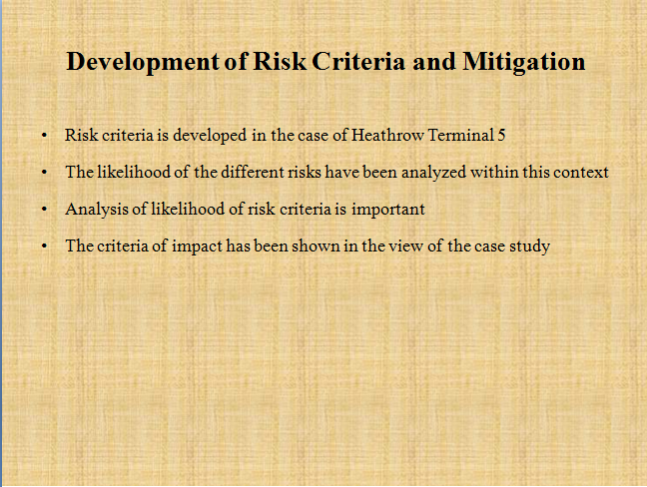

**Slide 1**

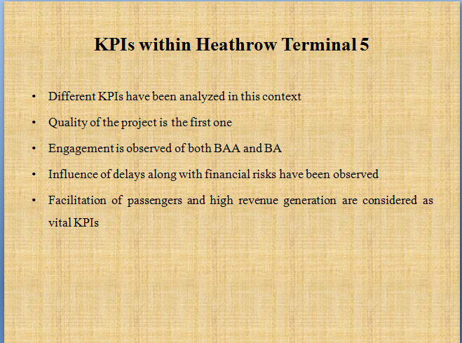

**Slide 2**

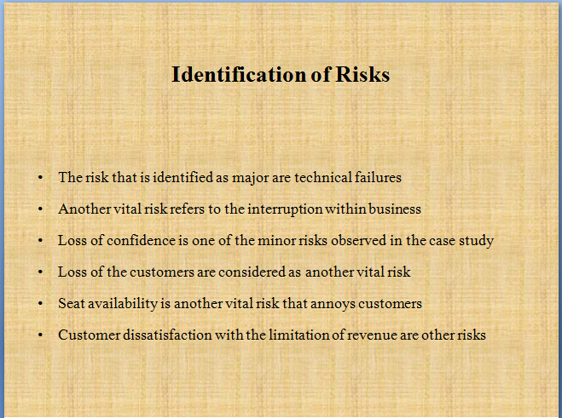

**Slide 3**

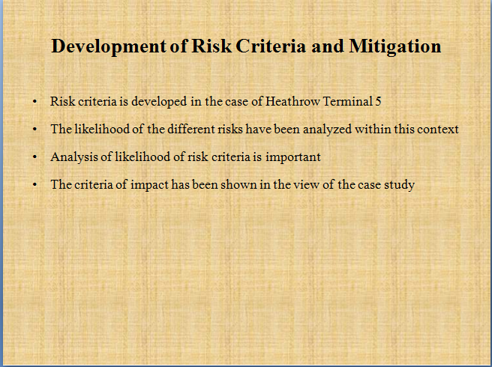

**Slide 4**

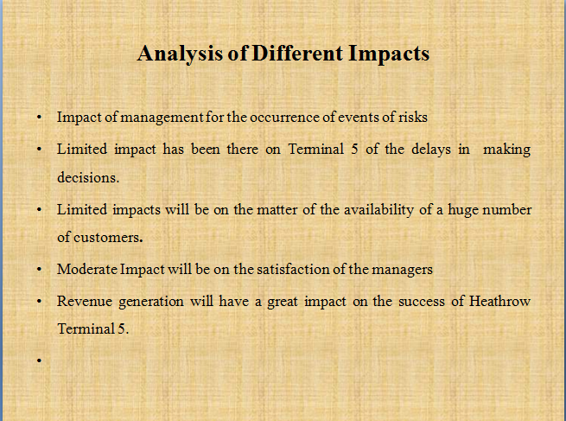

**Slide 5**

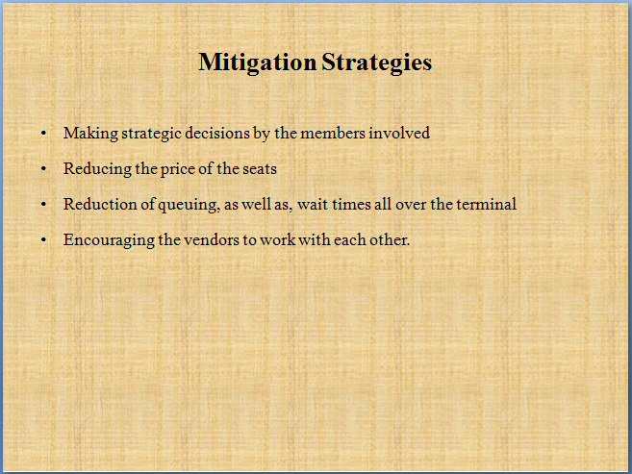

**Slide 6**

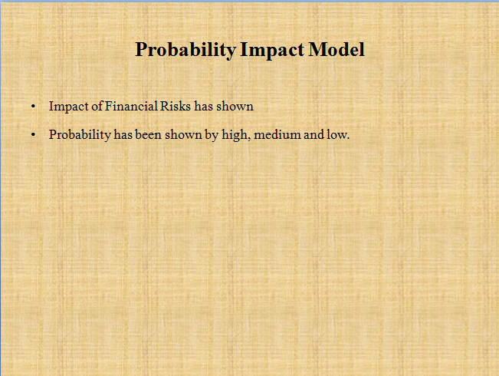

**Slide 7**

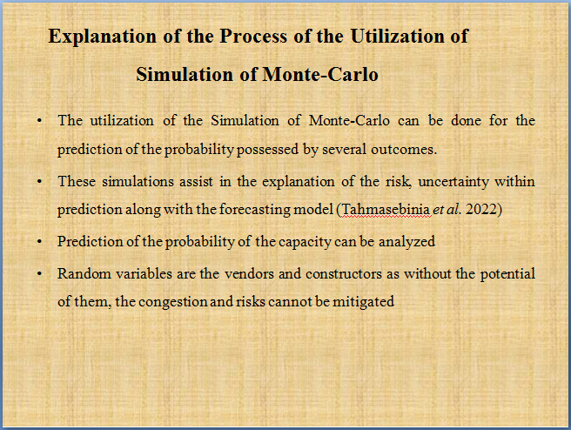

**Slide 8**

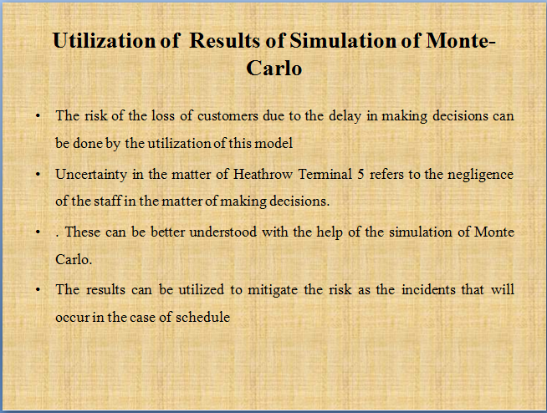

**Slide 9**

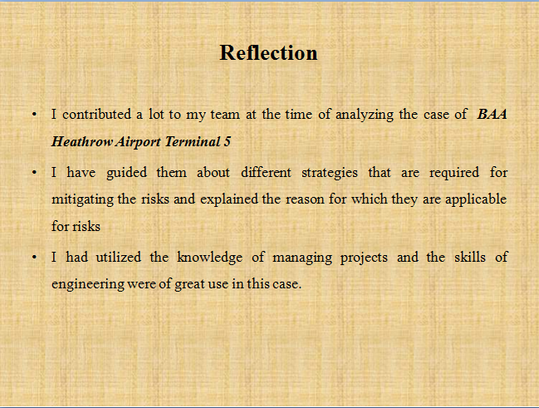

**Slide 10**